**Edge Attributes in NetworkX:**

Looking at the below network, we want to try and use NetworkX to extract information from the network.

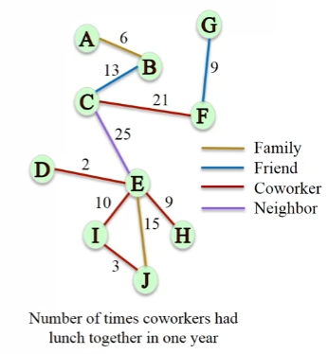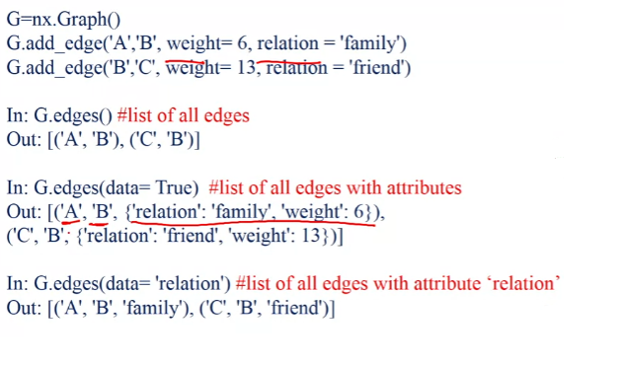

It is also possible to investigate only one of the connections between nodes: Note how because this in an **undirected network** so that the order doesn’t matter.

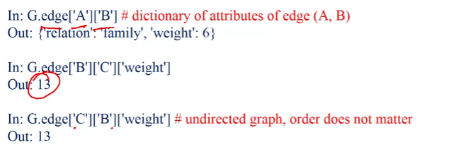

What about a **directional network**? The difference here is that the order of the attributes now matters.

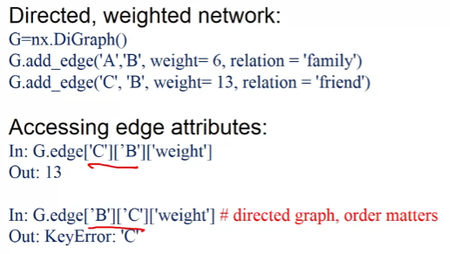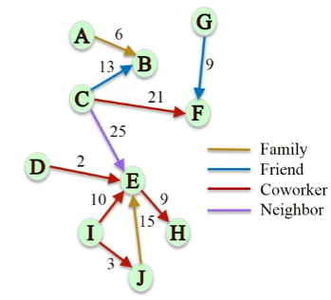

For **multi networks** when we call the attributes it returns a dicitonary of dictionaries, with each dictionary representing the individual edge bewteen the nodes. E.g. if you have 3 edges then you will have a dictionary of 3 dictionaries.

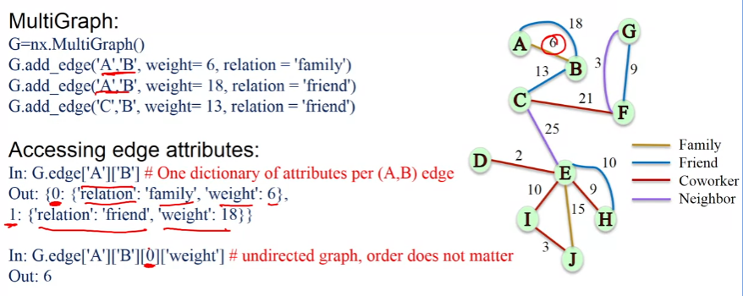

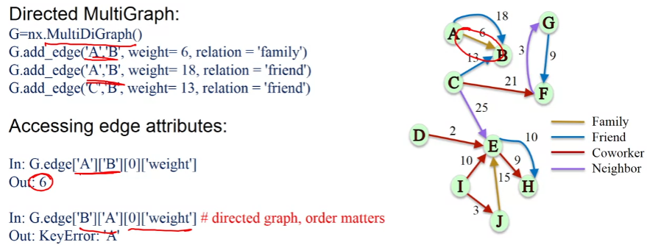

**Node Attributes in NetworkX:**

We can also put information into the node, for example, we could add the persons job title to their node.

